Brian Bauman

CSC 536

Final Project — Sample output

Depending on which example is chosen, different output will appear, but always in this format (a dump of the reduced results from each remote reducer).

The client window (for all three examples):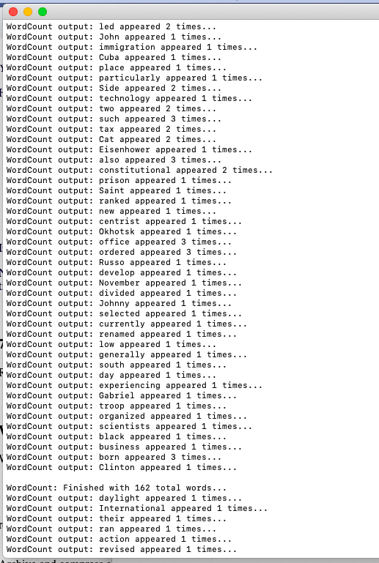

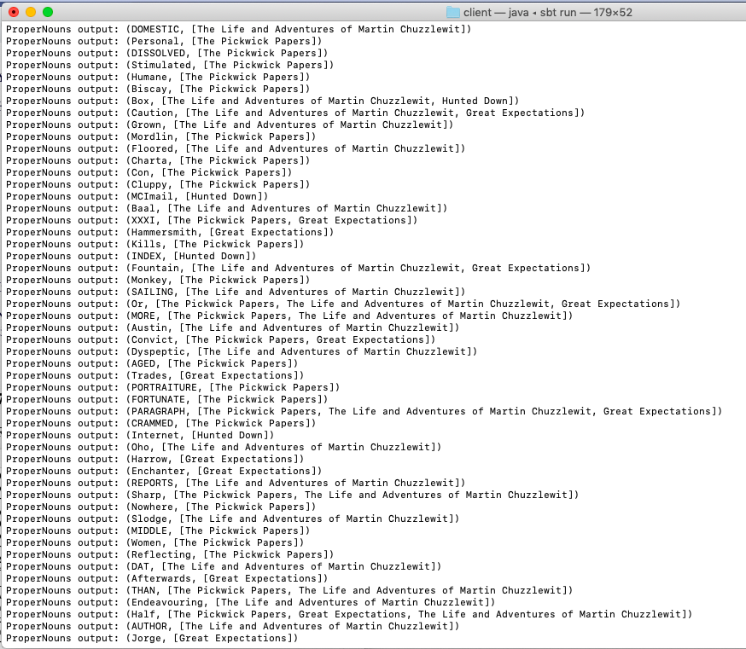

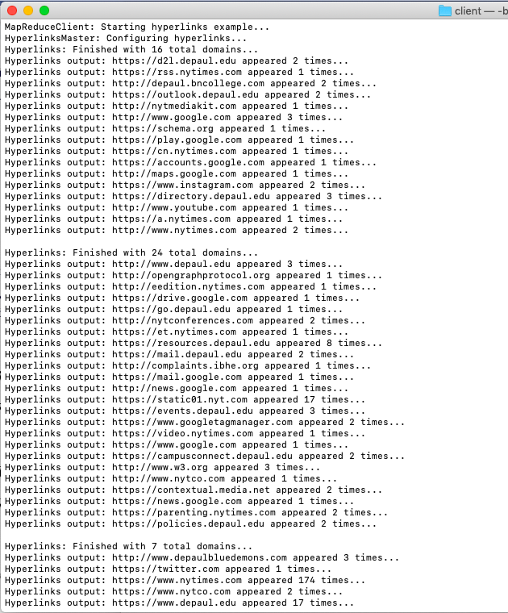

The server window (running both mappers and reducers):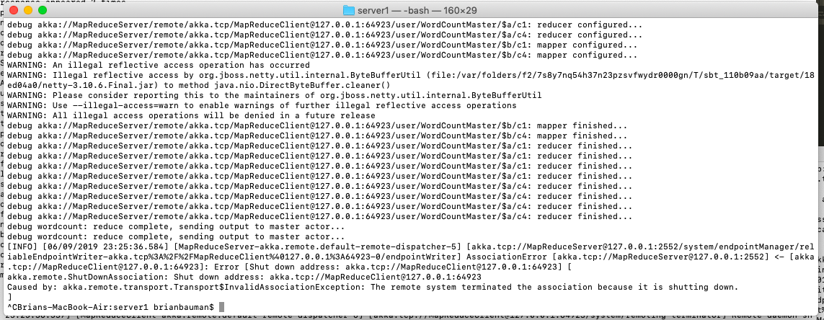

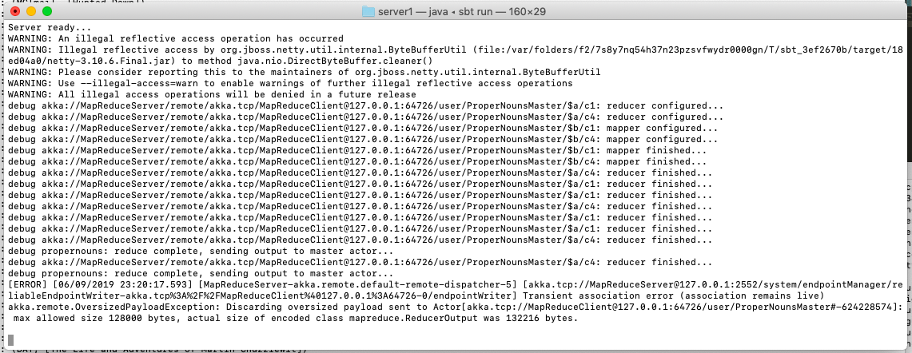

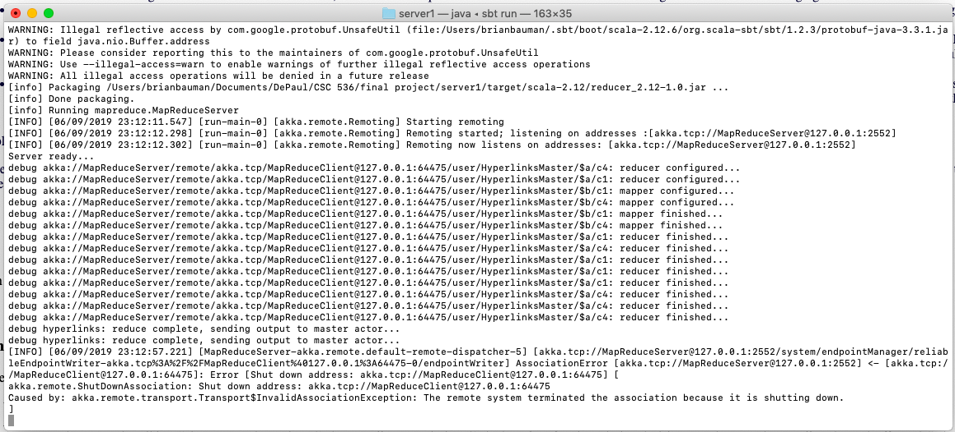(They really just log some detail, not much interesting going on in here. The name of the master actor changes but doesn’t have to. I just chose to create the client that way so the logs would be more obvious.)